**Project E-GeoBattery: (Edinburgh GeoBattery), Preparation for ISCF Proposal**

***Exploiting legacy mines to create a GEOthermal heat BATTERY***

The Advanced Computer Facility (ACF) located at Easter Bush, South of Edinburgh, have a projected increasing cooling requirement (Heat Load) of currently ~3MW and increasing to 7MW with potential longer term further increases. The University as owners of the ACF are looking into ways of providing low cost cooling whilst maintaining a relatively low carbon footprint. The possibility considered here is to use extensive legacy coal mine workings known to underlie parts of the Easter Bush site and extend northwards towards Edinburgh passing under a number of small communities, as a heat store during the initial phase of the project and as a potential source of heat for other users during later stages of the project. The aim is to provide a smart integrated heat, power and transport network.

The priority is to remove heat from the ACF facility. The second priority to establish longer tem business and societal use of the heat being stored within the workings.

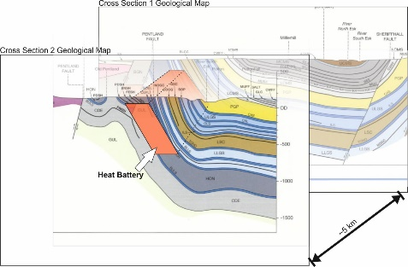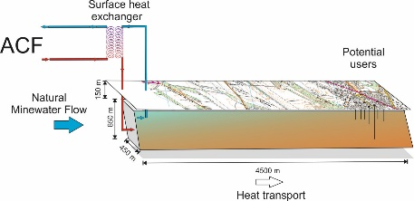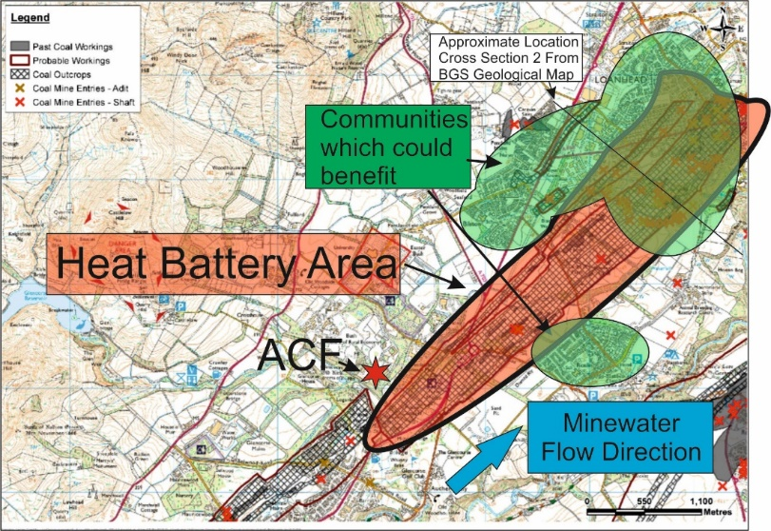

*Figure 1 Edinburgh-GeoBattery, concepts*

A three phased project is envisaged, with the following goals

* Phase 1 (Jan 2020 – Dec 2021): fully developed ‘investor ready’ business plan with a demonstrator plant
* Phase 2 (Jan 2022 – Dec 2023 ) : implementation of business plan, development of local industry and application of heat battery
* Phase 3 (Jan 2024 ff) : large scale development of heat battery concept.

The phase I design criteria are such that water is taken into the ACF facility cooling systems at 25C, and is expelled at up to 45C. Assuming a heat load of 10 MW for evaluation, this translates to a cooling requirement of ~120l/s of water from 45C to 25C. An initial estimate of the heat storage capacity of the proposed heat battery indicates that there is ample capacity to store more than 50 years of the heat from the ACF. This capacity can be used to store heat from, or provide balanced heat to multiple users spread throughout the regional influence of the heat battery.

A heat exchanger at the surface is envisaged transferring the heat energy from the ACF closed loop cooling system, to an extraction / injection scheme within the coal mine. It is likely that multiple levels and locations of injection and extraction will be necessary to ensure a longer term sustainable heat resource.

An existing scheme using similar workings for heat storage including a data centre has been operating for several years in Heerlen in the Netherlands.

**Key Points**

* ACF Low carbon low cost cooling
* Heat Storage
* Heat Transport by minewater flow
* Surface Heat exploitation in local communities

Heat Aspect: Storage and Recovery in Heat Battery, possible multiple location storage of access of heat// coolth

Power Aspect: Reduction in power required from Grid to run integrated system

Transport Aspect: Assessment of several options including the provision of SMART -charging points based on power savings, provision of water at optimum temperature for electrolyisis for H production

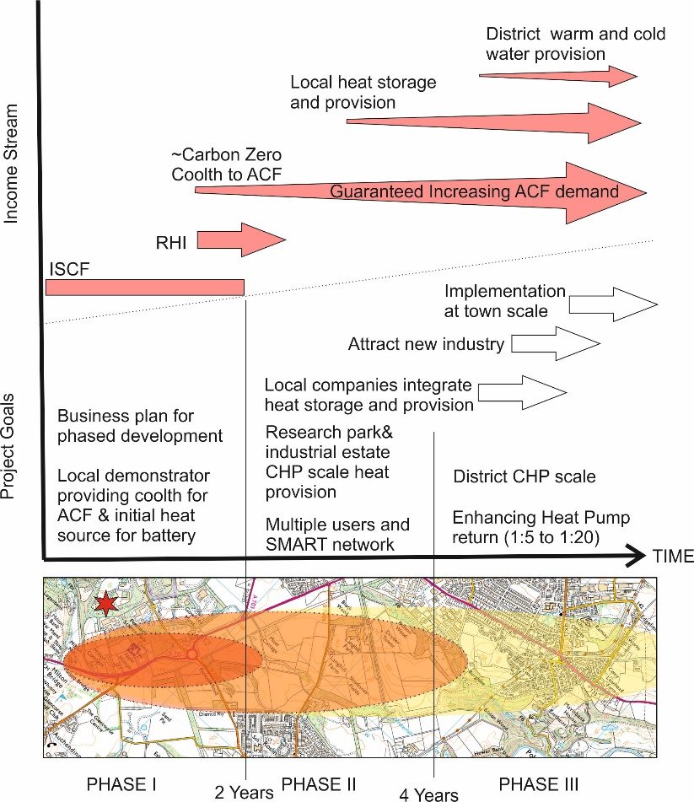**PHASE I Technical Aims of E-GEOBATTERY Proposal**

* Establish full feasibility study, including geotechnical, social and business plans to facilitate Phases II&III representing the gradual role out.
* Develop and install a lower capacity demonstration plant accessing subsurface “coolth” for the ACF
* Demonstrate viable income streams and advance the project to ‘investor ready’ status.

**Project planning and Income Streams**

Key project goals are illustrated against a time line, figure adjacent. These goals are couple with a gradual project role out.. The projected income stream classes from multiple users are illustrated in the upper part of this diagram. In particular we will investigate the potential to kick- start new regeneration schemes via the provision of a low cost, low carbon energy source.

**Contact details**

Dr. habil. Christopher McDermott, Reader in Hydrogeology and Coupled Process Modelling, University of Edinburgh, [christopher.mcdermott@ed.ac.uk](mailto:christopher.mcdermott@ed.ac.uk)

Andrew Gunning, Managing Director RSK Stirling, [AGunning@rsk.co.uk](mailto:AGunning@rsk.co.uk)

Dr. Simon Shackley, Lecturer, Lecturer in Carbon Policy, University of Edinbrugh, [simon.shackley@ed.ac.uk](mailto:simon.shackley@ed.ac.uk)